Question 9 [6 Points]
Write a C program to demonstrate zombie process prevention.
• Create multiple child processes
• Ensure terminated child processes do not remain zombies
• Parent process should print the PID of each child it cleans upUse fork(), wait(), or waitpid().
----
Script:
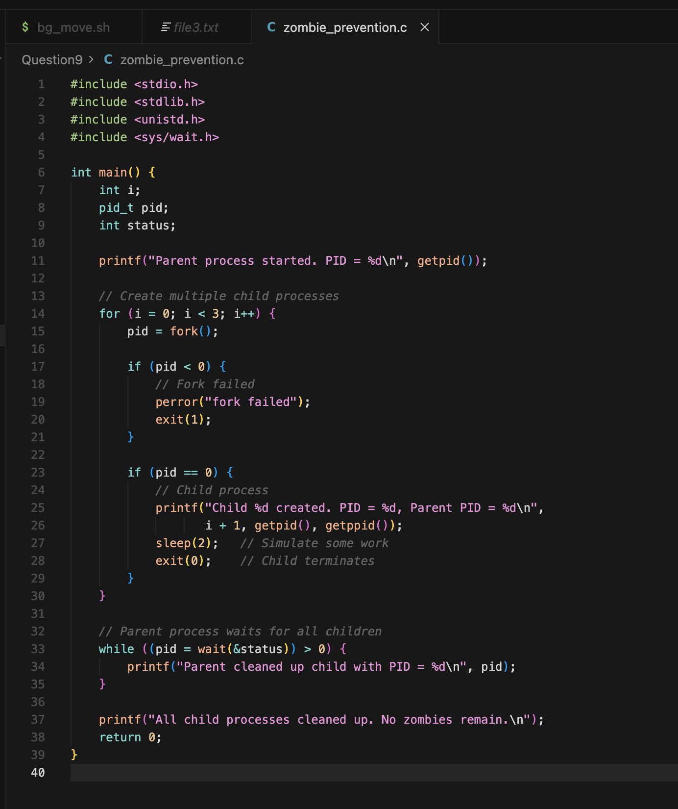

Outcome: